Sample User Requirements Headings

# Overview

* About the project and the module
* What problem are you trying to solve?
* High-level summary of the project
* Target market

# Project Team

* Names
  + Stephen Hughes, Fionnuala Hyndman, Michal Kos-Sliwinski, Jamie Lillicrap, Jack Keane
* Student Numbers
  + X00179579 SH, X00179539 FH, X00179021 MKs, X00172762 JL, X00170866 JK
* Roles and completed tasks per member

# Goals

* What are the aims of the project?
* Goals should be SMART:
  + **S**pecific
  + **M**easurable
  + **A**ssignable
  + **R**ealistic
  + **T**ime-Related
* Market Research
  + Surveys
  + Responses
  + Considerations

# Content Structure

* Define each page
* The type of content on each page
* A Chart showing the structure would be helpful.

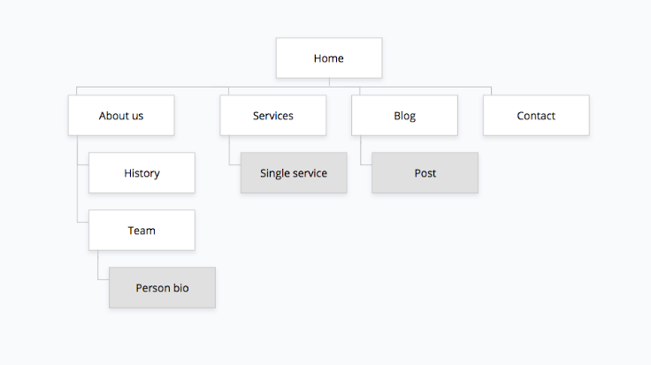

# Design

* CSS rules for the pages
  + Colours,
  + Types
  + Hover states
  + Spacing etc.
  + Responsive designs
* Branding
  + Logos
  + Footers

# Accessibility

* Different style considerations
* Different style sheets
* https://www.w3.org/WAI/standards-guidelines/wcag/

# Browser and Device Support

* What browsers should be used
* Phones, tables, ipad etc